14:45–15:30 Sara Contini, Reading
Oikeiōsis in Hierocles the Stoic and Its Significance to Origen Research – Ramelli's Translation of the Elements of Ethics

Coffee Break

15:45–16:30 Pui Ip, Oxford
Ramelli on the Birth of the Trinitarian Meaning of Hypostasis I: A Theological Reflection

16:30–17:15 Ryan Haecker, Cambridge
Ramelli on the Birth of the Trinitarian Meaning of Hypostasis II: A Philosophical Reflection

Coffee Break

17:30–18:15 Christian Pelz, Bochum
Freedom and Grace – The Concept of Salvation in Ramelli's Interpretation of Origen

18:15–19:00 Markus Wagner, Münster
Social Justice in Late Antique Christian Platonism – Origen’s Political Philosophy in Ramelli

Time
19th January 2019, 10–19
Place
Cambridge University, Clare College
Contact
Professor Douglas Hedley (Director)/ Dr Christian Hengstermann/ Dr Isidoros Ch. Katsos (Fellows)
ch766@cam.ac.uk/cik22@cam.ac.uk
rdh26@cam.ac.uk

Colloquium Adamantianum

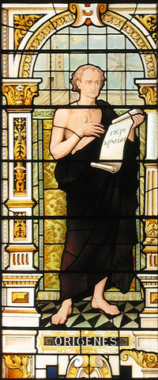
III. Apokatastasis and the Trinity
(Ilaria Ramelli)

Colloquium Adamantianum

Origen is the founder of Christian Platonism. The Colloquium Adamantianum is a workshop hosted by the Cambridge Centre for the Study of Platonism twice a year. Each of the Colloquia revolves around the research of one pre-eminent contemporary scholar on Origen and the Alexandrian tradition, exploring the Platonist origins of Christian metaphysics.

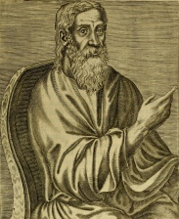
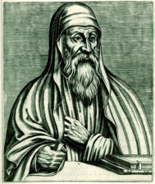
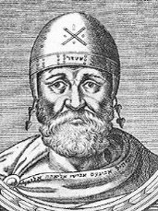

III. Apokatastasis and the Trinity

(Ilaria Ramelli)

In a series of seminal articles and monographs, including a monumental study on The Christian Doctrine of Apokatastasis, Ilaria Ramelli has defended the thesis of the compatibility between Christianity and philosophy (especially Platonism). Against the background of scholarly debates which tend to regard Christianity as anti-Platonism, Origen figures in Ramelli’s voluminous and interdisciplinary work as the archetypical example of the distinctive brand of Christian Platonism developed in patristic literature. Ramelli offers refreshing arguments for the identification of Origen the Christian with Origen the Neoplatonist. She defends Origenian exegesis as rooted in both Greek philosophy and Jewish-Christian Scriptures and literature. And she offers a compelling thesis for the inherent Hellenization of the Christian kērugma, exploring themes like freedom and morality, time and eternity, or trinitarian and hypostatic thought, in Origen and beyond.
Ilaria Ramelli: Apokatastasis
and the Trinity

10:00–10:15 Douglas Hedley, Cambridge
Introduction: Universal Salvation in Patristic Platonism – Christian Philosophy and Philology in Ilaria Ramelli

10:15–10:30 Ilaria Ramelli, Princeton
Apokatastasis and the Trinity in Origen

10:30–11:15 Adrian Mihai, Cambridge
One or Two? Ramelli and the Question of the Historical Origen

Coffee Break

11:30–12:15 Isidoros Katsos, Cambridge
Origen: A Christian Platonist of His Time? Re-visiting Ramelli’s Argument in Light of Edwards

12:15–13:00 Christian Hengstermann, Bochum
Individual and Universal Salvation – The Restitution of All Things in Biblical and Patristic Thought in Ramelli’s Apokatastasis

Lunch Break

14:00–14:45 Pia de Simone, Cambridge/Milan
Terms for Eternity in Ancient and Christian Philosophy: Ramelli on the Quest for Timelessness

